**Working Paper 2**

Version 1 (WP2.1)

18th November 2021

Author

Dr.Thanapon Piman, SEI

Chinaporn Meechaiya, ADPC

Md. Kamal Hosen, ADPC

**Documentary**

|  |  |  |  |
| --- | --- | --- | --- |
| **No** | **Documentary** | **Purpose** | **Date** |
| 1 | The RAT Mekong: WP2.1 | To present the first Mockup Version of the RAT-Mekong tool | 18 November 2021 |

**Developer team**

|  |  |  |  |
| --- | --- | --- | --- |
| **No** | **Name** | **Organization** | **Email** |
| 1 | Prof. Faisal Hossain | University of Washington | fhossain@uw.edu |
| 2 | Mr. Pritam Das Graduate | University of Washington | pdas47@uw.edu |
| 3 | Prof. Hyongki Lee | University of Houston | hlee45@central.uh.edu |
| 4 | Chinaporn Meechaiya | ADPC | chinaporn.m@adpc.net |
| 5 | Md. Kamal Hosen | ADPC | kamal.hosen@adpc.net |
| 6 | Dr.Thanapon Piman | Stockholm Environment Institute | thanapon.piman@sei.org |
| 7 | Uttam Ghimire | Stockholm Environment Institute | uttam.ghimire@sei.org |





Table of Contents

1. Background 5

2. Objectives of the RAT-Mekong 5

3. Objectives of the WP2 6

4. Conceptual Framework for RAT-Mekong Tool 6

5. Infrastructure 9

5.1 Hardware Requirements 9

5.2 Operating System (OS) 9

5.3 Internet Connection 9

6. Backend Development 10

6.1 OS System (OS) 10

6.2 Installation of Python, Anaconda and Other Dependencies 10

6.3 Python Django Frameworks 10

6.4 Setup VIC Model 10

6.5 Setup GEE Python API 10

6.6 PostgreSQL Database 10

6.7 NGINX Web Server 10

7. Design of User Interface 11

7.1 Home Page 11

7.2 About Page 11

7.3 User Guide 11

7.4 Map Viewer Page 11

7.4.1 Map View 11

7.4.2 Table View 19

8. Hosting/Deployment Recommendation 21

List of Figures

Figure 1: Storage change calculation process 7

Figure 2: Inflow calculation process 8

Figure 3: Conceptual Framework 8

Figure 4: Map view section 12

Figure 5: Filter Panel 13

Figure 6: Map showing reservoir filter by country Thailand 13

Figure 7: Map showing reservoir filter by river basin Chi 14

Figure 8: Layer panel showing toggle on River Sub-basin layer overlay on basemap 14

Figure 9: OSM Default Basemap 15

Figure 10: Switching default OSM basemap to Satellite Map 15

Figure 11: Popup showing area elevation curve of Nam Theun 2 reservoir 16

Figure 12: Popup showing the time series of inflow changes of Nam Theun 2 reservoir 17

Figure 13: Chart options 18

Figure 14: Downloading chart as PNG image format 19

Figure 15: Table view showing storage change data of all reservoirs in tabular form 20

Figure 16: Table view showing storage change data filtered by country Vietnam 20

Figure 17: Table view showing rule curve data data filtered by river basin Chi 21

# Background

SERVIR-Mekong (<https://servir.adpc.net/>) works in partnership with leading regional organizations to help the five countries in the Lower Mekong Region use information provided by Earth observing satellites and geospatial technologies to manage climate risks. The region includes Cambodia, Lao PDR, Myanmar (Burma), Thailand and Vietnam. The Asian Disaster Preparedness Center (ADPC), a recognized leader in strengthening disaster resilience in Asia, is the prime implementer for SERVIR-Mekong. Three other consortium partners, Spatial Informatics Group (SIG), Stockholm Environment Institute (SEI) and Deltares, assist in implementing the SERVIR-Mekong program and bring exceptional capabilities to help deliver services to the region.

**R**eservoir **A**ssessment **T**ool for Lower **Mekong** Basin (**RAT-Mekong**) under the SERVIR-Mekong program is developing to support information on reservoir monitoring to the MRC and its member countries in decision making and planning processes for flood and drought management in the Lower Mekong Basin (LMB). **The RAT-Mekong is Near Real-Time reservoir monitoring tool using satellite observations and hydrologic model** (Biswas et al 2021). The tool will fill the data gap in reservoir monitoring at the basin scale due to limited in-situ data and restriction of data-sharing policy. At present, reservoir information in the Upper and Lower Mekong Basins is important for drought and flood management downstream.

The RAT-Mekong will support the MRC in development of indicator monitoring of the MRC’s Drought Management Strategy (DMS) 2020-2025 which is referred to reservoir monitoring indicator as well as MRC’s Flood Management and Mitigation (FMM) Strategy 2021-2030. The tool has been identified in the MRC Multiyear work plan 2021-20222 under task 4.1.4.1.7 Develop reservoir assessment tools with ADPC and other partners. Moreover, the reservoir information such as estimated inflows, outflows and storage changes from the RAT-Mekong have potential to support and facilitate implementation of the MRC Procedures including for Procedure of Data Information Exchange and Sharing (PDIES), Procedure for Water Use Monitoring (PWUP) and Procedure for the Maintenance of Flow on the Mainstream (PMFM) of the Mekong River.

The concept note of the RAT-Mekong is presented to the 7th Regional Expert Group Meeting on Data Modelling and Forecasting (EGDFM) on 3rd March 2021. The member countries acknowledged and approved the RAT-Mekong after the Expert Group Meeting to develop a tool to monitor Near Real-time (bi-weekly) reservoir behavior and reservoir operating rules based on long term records are made available to the public, which can be helpful in data-scarce, or data restricted in the basin.

# Objectives of the RAT-Mekong

The overall objective of the RAT-Mekong ***is to provide near-real-time reservoir monitoring information to assist the MRCS and Member Countries in decision and planning process for drought and flood management in the Lower Mekong Basin***. Followings are specific objectives of this tool development.

1. To regularly estimate changes in reservoir storage, surface area, inflow, outflows, and inferred reservoir rule curve (Bonnema et al. 2016; 2017).
2. To develop a user-friendly web-interface system to share reservoir monitoring information and integrate into MRC data portal for MRC and relevant users in the Member Countries.
3. To support MRC to develop reservoir monitoring indicators for decision making and planning in drought and flood management.
4. To build capacity of the MRCS and Member Countries to enhance reservoir assessment capability using satellite observations and the hydrologic model.

# Objectives of the WP2

The SERVIR-Mekong team is developing the web interface as well as the backend of the RAT-Mekong tool as requested by MRC technical team to represent this tool to its member countries. On 10th November 2021, the SERVIR-Mekong team has organized the technical meeting with the MRCS team to present and discuss the 2nd mockup version of the RAT-Mekong tool. The key suggestions, requirements and feedbacks have been identified from the MRCS team to update the web interface.

The main objectives of this working paper is to present the core concept of the RAT-Mekong tool development, the infrastructure for hosting this tool, the process of backend development and represent the frontend/user interface development to the MRCS technical team and the Member countries to seek suggestions, modifications, upgradations and agreement. The WP2 also presents the various functions of this tool and its uses.

# Conceptual Framework for RAT-Mekong Tool

Reservoir Assessment Tool (RAT) is a cloud optimized integrated satellite remote sensing and web-based visualization tool to monitor reservoirs at near real time scale. The RAT-Mekong tool have two parts – backend and frontend. The backend holds the model, logic and processing of data. The frontend contains the user interface to visualize the desired outputs processed in the backend in map, chart and tabular format.

In the backend part of this tool, there have three main modules - Storage Change Module, Data Download Module and Model Simulation and Post-Processing Module to estimate the reservoir inflow, outflow, and storage changes. A task scheduler is setup with defining task duration to automate the estimation of the entire backend process.

**A. Storage Change Module**

The storage change module, written in a python programming language, is used to produce reservoir surface area time series. First, it selects a single reservoir from the reservoir database of the RAT framework. Then it creates a buffer polygon around the reservoir based on the distance provided. It selects all the available satellite imageries (of a selected sensor) and removes cloud and cloud shadow using a bit-masking algorithm. After removing the scenes with higher than threshold cloud cover, it mosaics all the scenes and applies the threshold-based method to create the water area of the reservoir. Finally, using the area-elevation relationship curve and the water area time series, it calculates the storage change for the selected reservoir. The module iterates all the reservoirs in the same way and generates the reservoir storage change time series for every reservoir.

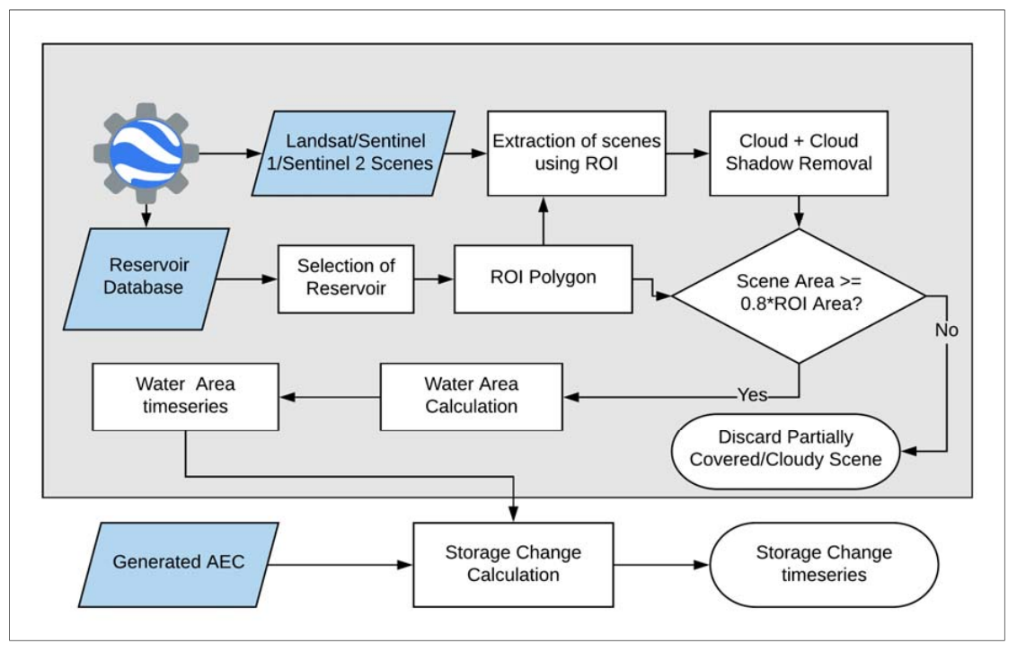

Figure 1: Storage change calculation process

**B. Data Download Module**

The VIC model requires different types of meteorological parameters like precipitation, minimum and maximum temperature, wind speed, etc. to run VIC and Routing model to estimate reservoir inflow. The data download module is developed to download the required data from the relevant portal and reformat & resample into a specific format to run the VIC simulation model.

**C. Model Simulation and Post-Processing Module**

This module is used to run the VIC and Route model to get the latest available reservoir inflow data. After estimating the inflow, the outflow is calculated based on this inflow data and storage change data of the particular reservoir.

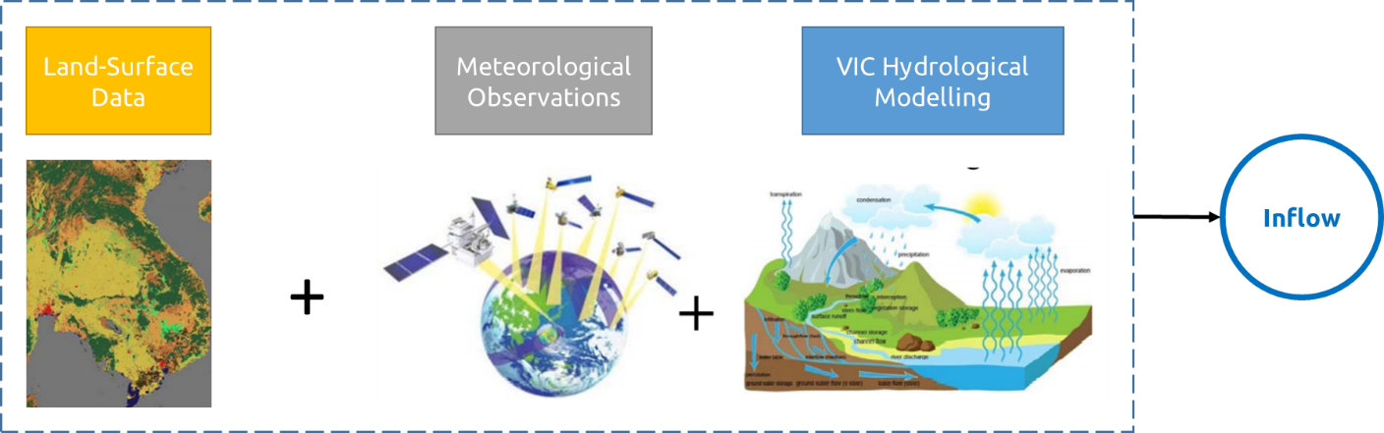

Figure 2: Inflow calculation process

In the frontend part, the user interface is built to visualize the time series inflow, outflow and storage change along with the area elevation curve, rule curve, and surface area of each reservoir.

The overall conceptual frameworks of the RAT-Mekong tool is shown in the Figure 03.

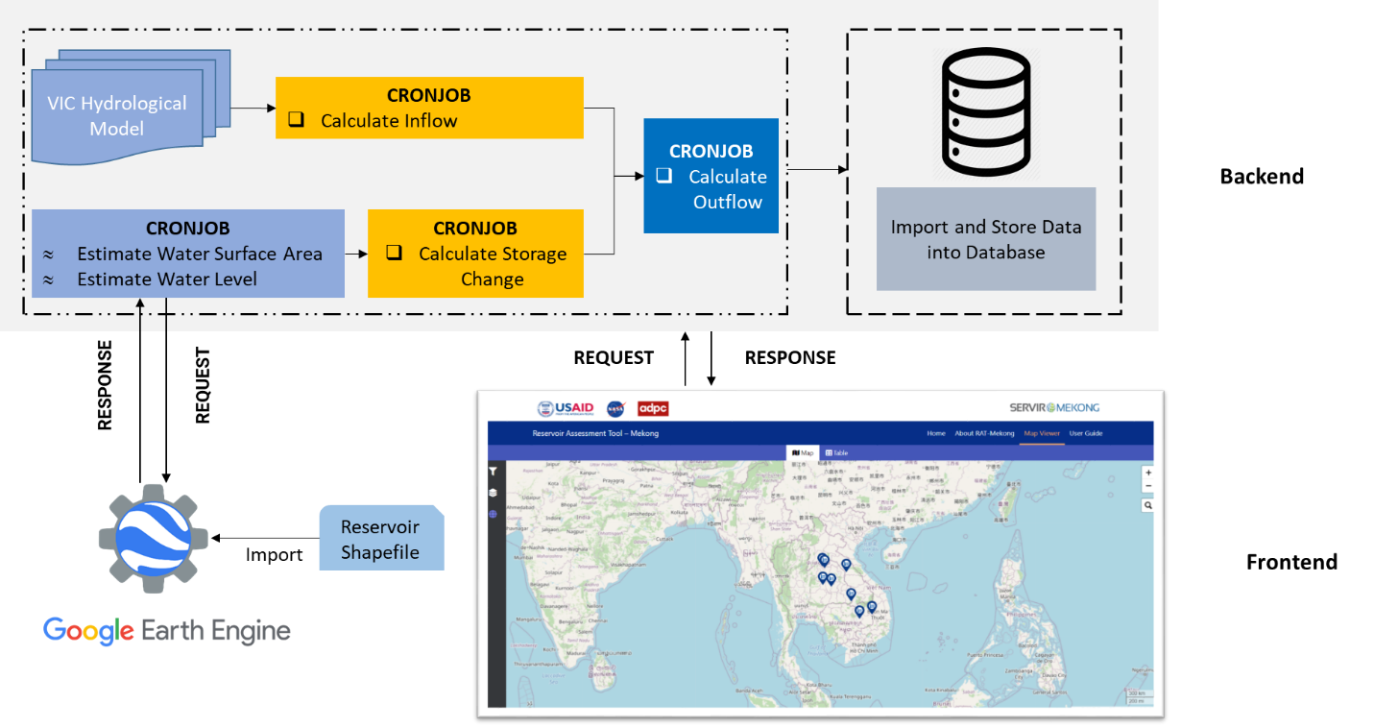

Figure 3: Conceptual Framework

# Infrastructure

The RAT-Mekong tool have a hardware, good internet connectivity and operating system (OS) dependencies. This infrastructure is required to host, serve, operate and manage the RAT-Mekong tool.

## 5.1 Hardware Requirements

The RAT-Mekong tool is a near real time reservoir monitoring tool which runs the VIC hydrological model to compute the daily inflow of the given reservoirs based on the climatic and meteorological conditions of the surrounding areas, bi-weekly derived the water surface area from satellite data using google earth engine python API in the backend. The backend outputs are further processed again to prepare the expected outcomes and served it directly to user by applying frontend techniques. The entire process is automated by a task scheduler. There is no need of human interactions after setting up the backend and frontend properly. Hence, a high computation workstation or server is required for smoothly running and serving RAT-Mekong Tool. A sufficient disk space is required to store the data/outputs generated from the model and post processing. Below is specified the minimum and recommended requirements for the RAT-Mekong Tool –

Table 01: Hardware requirements for hosting RAT-Mekong tool

|  |  |  |
| --- | --- | --- |
|  | **Minimum Requirements** | **Recommended Requirements** |
| CPU | 8 Core Intel i7 / i9 | 32 Core Intel Xeon Gold @3.0 GHz |
| RAM | 128 GB | ≥ 180 GB |
| Hard Disk Storage | 1 TB HDD/SSD | 2 TB HDD/SSD |
|  |  |  |

## 5.2 Operating System (OS)

The VIC Hydrological model is a Linux-based model developed by the University of Washington. A Linux-based operating system like Ubuntu is required to run the VIC model. So, the Linux Ubuntu 21.04/20.04 LTS server is recommended to set up and host RAT Mekong Tool. The existing RAT-Mekong mock version 2 is hosted on Ubuntu 20.04 LTS server owned by ADPC.

## 5.3 Internet Connection

A high speed internet connection is required to server this tool. Hence, a high-end Wi-Fi router device, cable connection, firewall setup etc. is required.

Alternatively, the MRC can purchase a manage cloud infrastructure from cloud services provider like AWS, GCP etc. to avoid the complexities of installation, setup and maintenance of their own infrastructures.

# Backend Development

The core components and requirements for running the RAT server in the backend system are discussed below –

## 6.1 OS System (OS)

Linux Ubuntu 20.04 LTS server is used to set up the backend part of the RAT Mekong Tool.

## 6.2 Installation of Python, Anaconda and Other Dependencies

Python is required to run the RAT modules. The latest compatible python version along with the Anaconda python package manager is used to manage the dependency and control the version of different python packages/libraries.

## 6.3 Python Django Frameworks

A python Django web framework is used as the server-side framework to hold the backend functionalities/logic and connect the backend with the frontend. A virtual environment is created install Django and other packages/libraries using pip.

## 6.4 Setup VIC Model

The latest version of VIC (Version - 5) and route model will be set up using conda to get the latest available inflow data of the desired reservoir. These tasks will be automated by a task scheduler for every reservoir.

## 6.5 Setup GEE Python API

Google Earth Engine (GEE) python API will be set up and used to process the Landsat/sentinel-1/sentinel-2 satellite imagery and estimate the water surface area of the reservoir which is required to calculate the storage change. A Google Earth Engine account is required to use earth engine resources in the RAT-Mekong tool.

## 6.6 PostgreSQL Database

A PostgreSQL database is installed and used to store the relevant data required for the RAT-Mekong tool.

## 6.7 NGINX Web Server

A NGINX web server is set up and used to optimize client-server interactions by handling HTTP requests and responses.

# Design of User Interface

The frontend is developed using open sources tools/libraries such as Leaflet JS, Bootstrap 5, Highcharts etc. along with HTML5, CSS3, JavaScript, JQuery. The front end has contained four pages – Home, About, Map Viewer and User Guide.

## 7.1 Home Page

The home page contains the navigation menu, footer menu, the relevant information of the RAT tools like the team, partners, short descriptions of the RAT-Mekong tool etc. in the body section.

## 7.2 About Page

The about page contains the short descriptions, methods, purposes, uses, and impacts of the RAT tool.

## 7.3 User Guide

The user guide page describes how to use the RAT tool and its functionalities.

## 7.4 Map Viewer Page

The map viewer page has two subsections – map view and table view which are controlled by tab functions. When the user clicks on the map tab, it shows the map tab content and when to click on the table tab, the table tab content will show on the body section. The details of each section are described below –

### 7.4.1 Map View

The map subsection has a sidebar panel and a map panel.

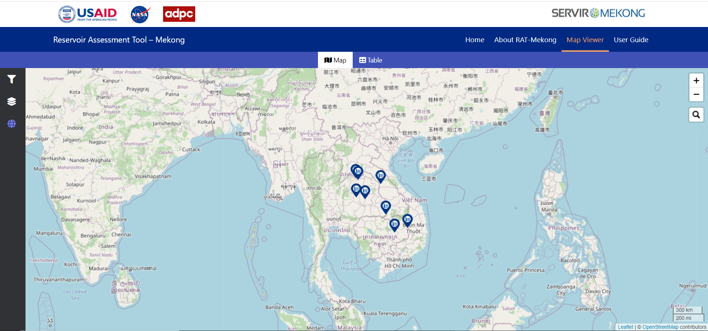

Figure 4: Map view section

There is a sidebar in the left of map view section. There have three navigation menu – filter panel, layer panel and basemap panel. When the user click on the any menu icon, it will expand in a certain width and overlay on the map. The expanded area shows the related content of the menu. The detail of each menu item and its functionalities are discussed below.

#### 7.4.1.1 Query/Filter Panel

By clicking on the query/filter menu, the filter options will show in the content panel. Users can able to filter the reservoir by different query parameters such as filter by country, filter by river basin, etc. By default, all of the reservoirs will show on the map when the map page will load for the first time. When user clicks on the dropdown filter box, it will expand. There have a check box representing as filter. User can able to check and uncheck it by mouse click. By checking it will show the related reservoir and by unchecking it will hide the related reservoirs on the map. The figure 06 shows the Thailand reservoirs on the map by checking it on mouse click and the rest reservoirs hide from the map. Similarly, the figure 07 shows the Lam Pao reservoir by filtering the Chi river basin.

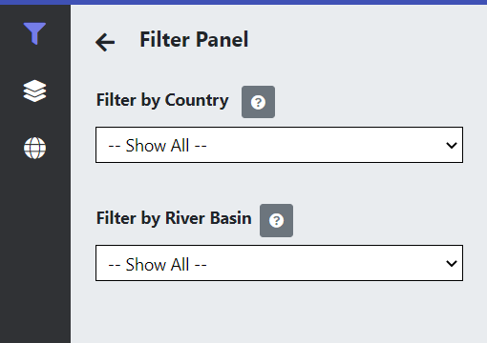

Figure 5: Filter Panel

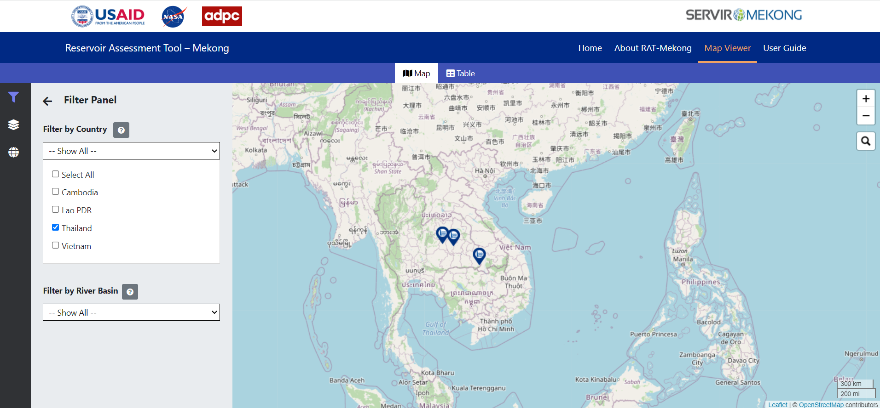

Figure 6: Map showing reservoir filter by country Thailand

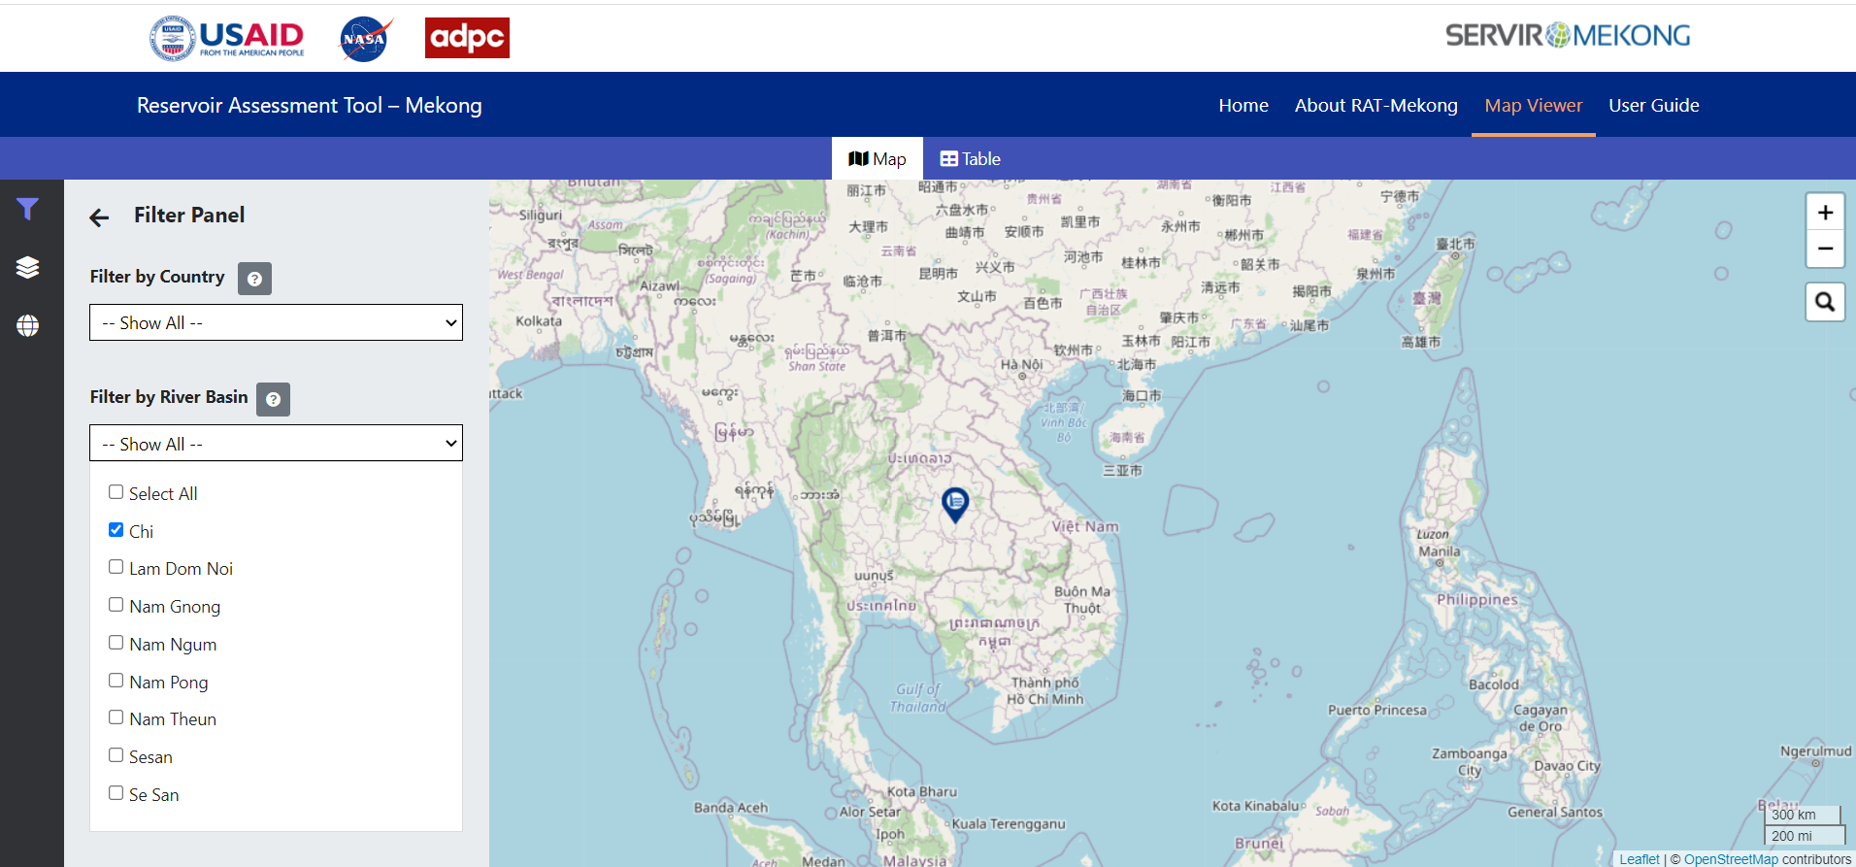

Figure 7: Map showing reservoir filter by river basin Chi

#### 7.4.1.2 Layer Panel

The layer panel has the associated layers such as the Mekong boundary, country boundary of the Mekong region, rivers etc. A toggle switch on/off is used to turn the on/off of a specific layer. By turning on the layer, it will overlay on the basemap and it will be hidden when turn off.

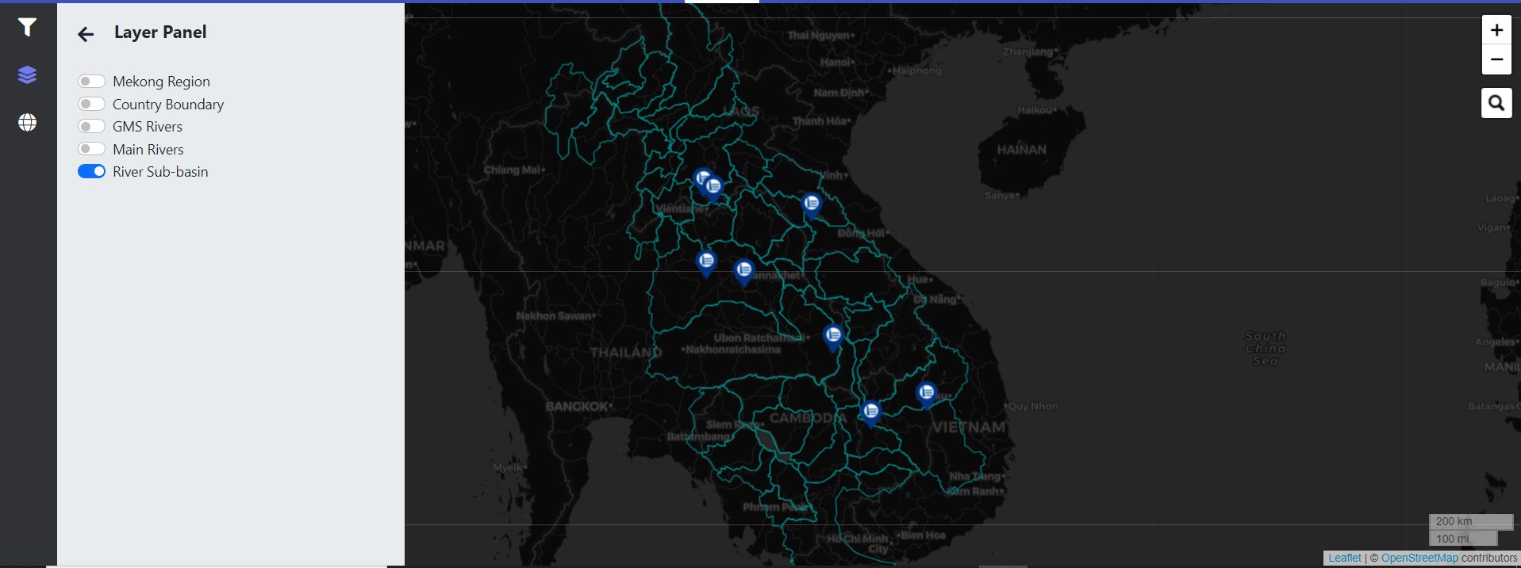

Figure 8: Layer panel showing toggle on River Sub-basin layer overlay on basemap

#### 7.4.1.3 Basemap Layers

Different types of base map layers such as satellites, streets, OSM, topographic, etc. will include in the Basemap layer panel. When a user clicks on the globe icon from the sidebar menu options, all of the base maps with a card will display in the sidebar content area. Users can easily switch from one base map to another base map by selecting the card option. When clicking on the card, it will be highlighted and the relevant base map will add to the map panel. Primarily, Open Street Map (OSM) is chosen as the default basemap.

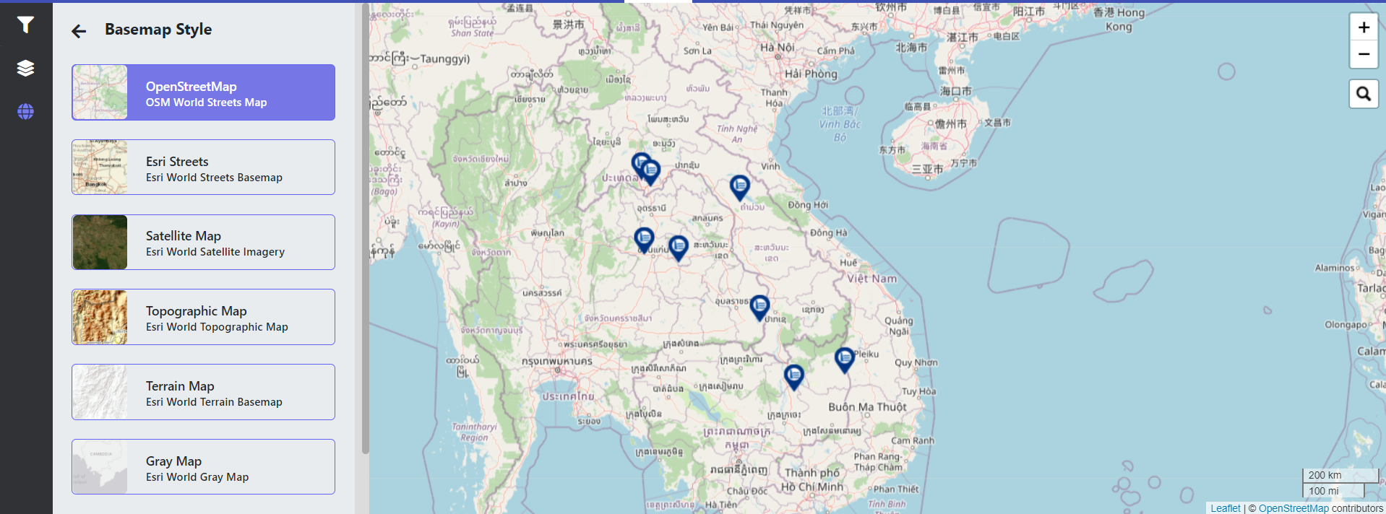

Figure 9: OSM Default Basemap

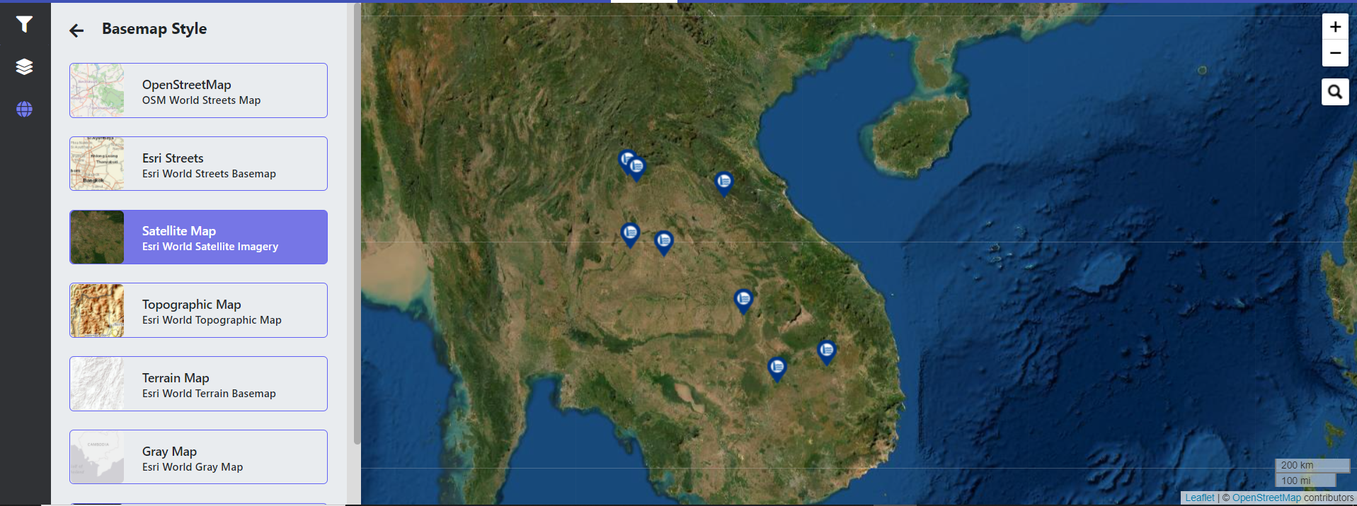

Figure 10: Switching default OSM basemap to Satellite Map

#### 7.4.1.4 Popup Information Panel

The information menu will display the associated information and graphs of each reservoir. When the user clicks on a dam/reservoir from on top of the map, a popup will open and a switchable tab function will use to show the dam/reservoir-related information like inflow, outflow, storage change, area elevation curve (AEC) etc. When the user clicks on a specific tab button, it will show the tab-related information.

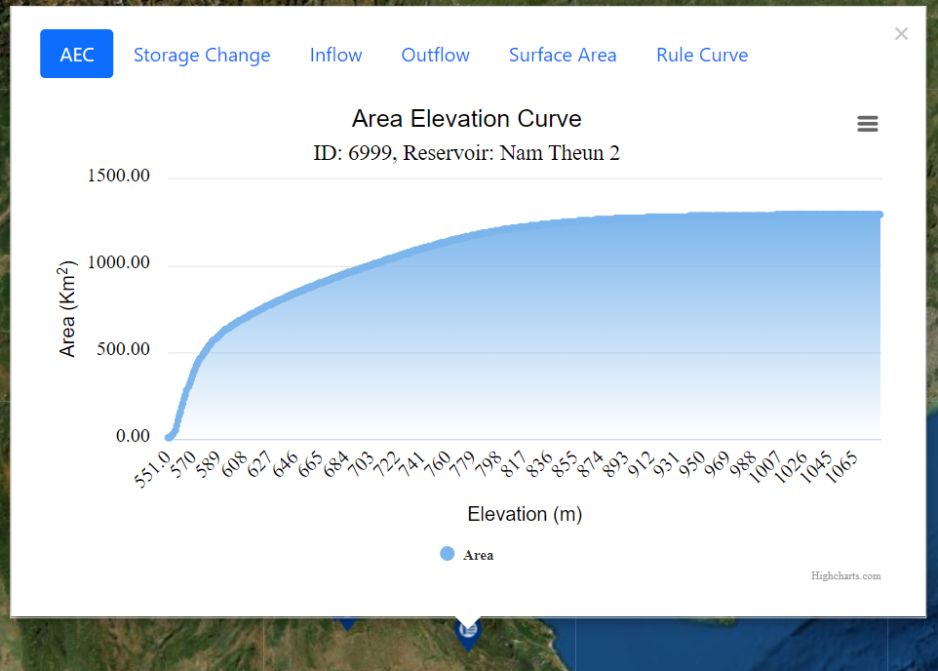

Figure 11: Popup showing area elevation curve of Nam Theun 2 reservoir

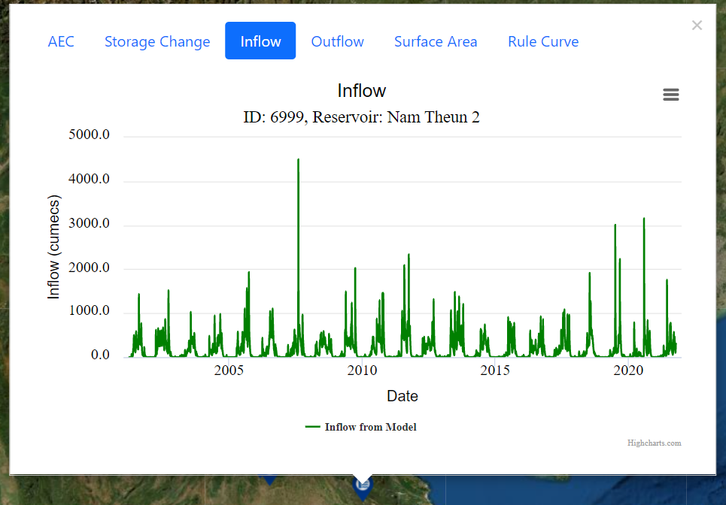

Figure 12: Popup showing the time series of inflow changes of Nam Theun 2 reservoir

Each chart has a download options (bar icon). When users click on this icon, it will expand and shows different options – view in full screen, print chart and download chart as PNG, JPEG, PDF, SVG format. By clicking view in full screen, it will open the chart in full screen mode. By clicking on the download button, the chart image will be downloaded in selected format.

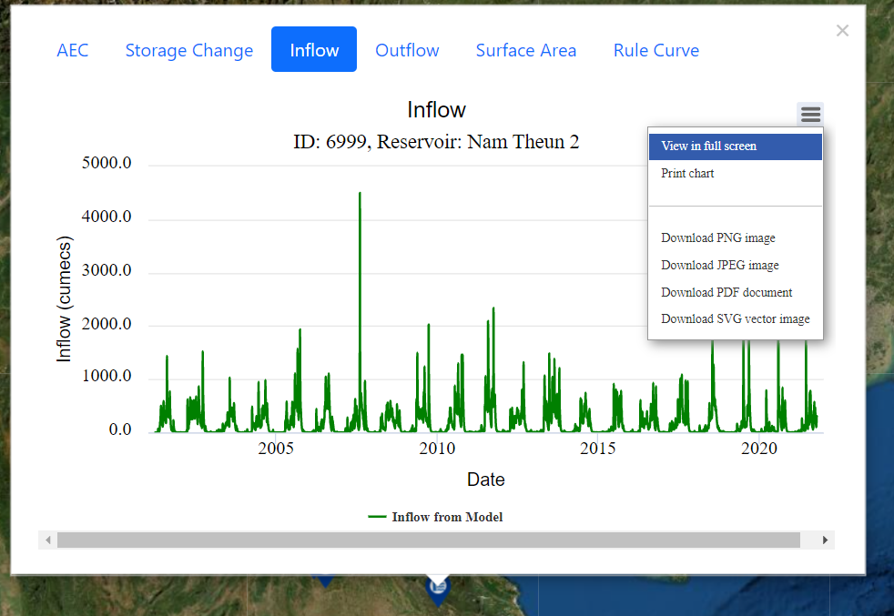

Figure 13: Chart options

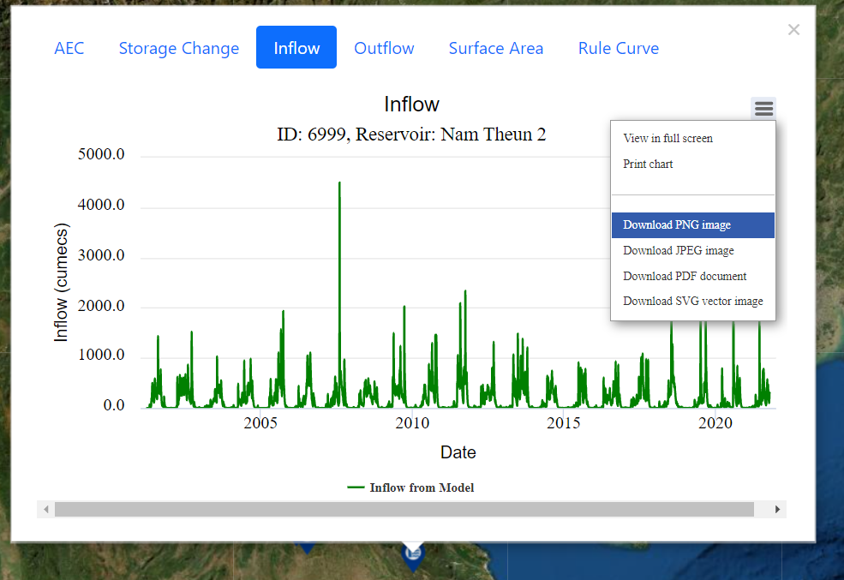

Figure 14: Downloading chart as PNG image format

### 7.4.2 Table View

The table view section is showing the details of the reservoir/dam information in a tabular format. There have six tabs – AEC, Storage change, Inflow, Outflow, Surface Area, and Rule Curve. User can easily switch from one tab to another tab by a mouse click event. Each tab has contained the tab-related information of all the reservoirs. Each tab has also a filter function to filter reservoir in a certain criterion and the results will show the associated information of the filtered reservoir/dam in the table.

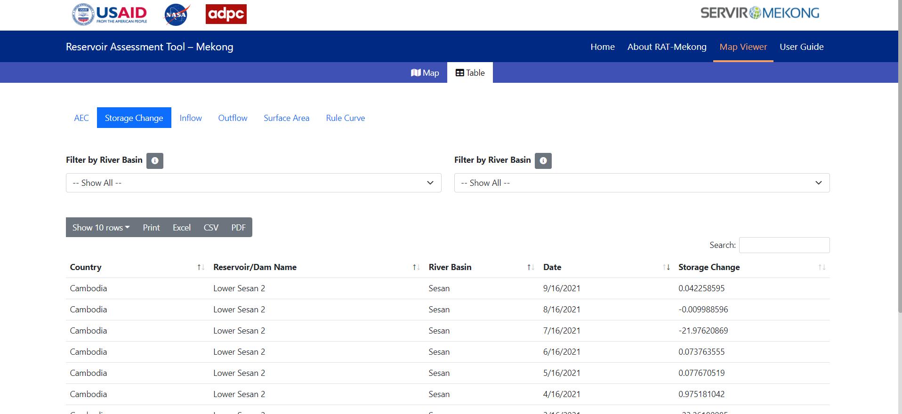

Figure 15: Table view showing storage change data of all reservoirs in tabular form

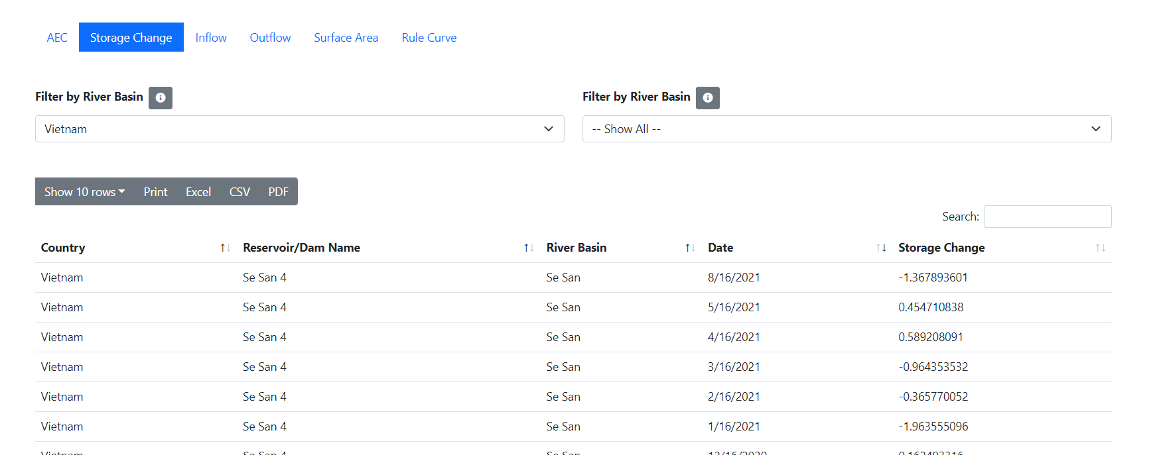

Figure 16: Table view showing storage change data filtered by country Vietnam

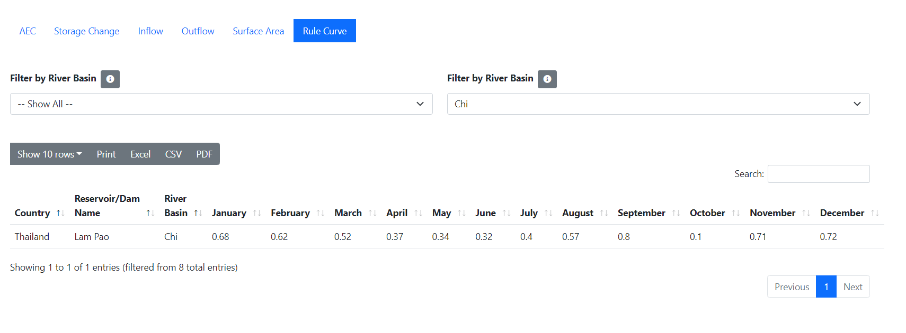

Figure 17: Table view showing rule curve data data filtered by river basin Chi

# Hosting/Deployment Recommendation

Initially, the RAT-Mekong tool will be set up into the ADPC server to test it with the guidance of the AST team. When the testing will be completed, the RAT tool web address will be published to the public and linked to the MRC website so that the RAT-Mekong tool can be accessed from the MRC website too. After that, the entire RAT-Mekong tool will be setup into the MRC server and it will be directly linked to the MRC website by a specific domain preferred by MRC.